nox NightTimeExpress  De Liesbosch 90  3439 LC Nieuwegein  Telefoon +31 (0)30 6083850  Email occ@nox-nighttimeexpress.nl | 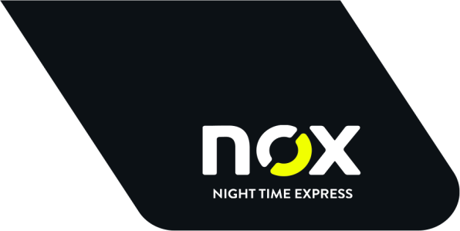  REPLY CARD  CLOSING DAYS 2019
Your details:
Company
Address of pickup

Name contact
Please indicate your choice
Would you like a shift of your regular pickup day?
☐Yes
If yes: shift to? Please mention your preferred date

Do you have extra closing days on which distribution is provided and not needed?
☐Yes
If yes: Please mention the date

Do you need pickup goods on a day mentioned in our Closing days 2019?
*Additional cost will be charged
☐Yes

If yes: Please mention date, hour for pickup en volume

